Challennge 1: G_

>> ghex Screenshot(722).png

You will get to see many chunks to correct:

1)PnG

2)IDatx^(3)

3)IEnd

4nD N0w U 6ot ThE Fl46!!!!

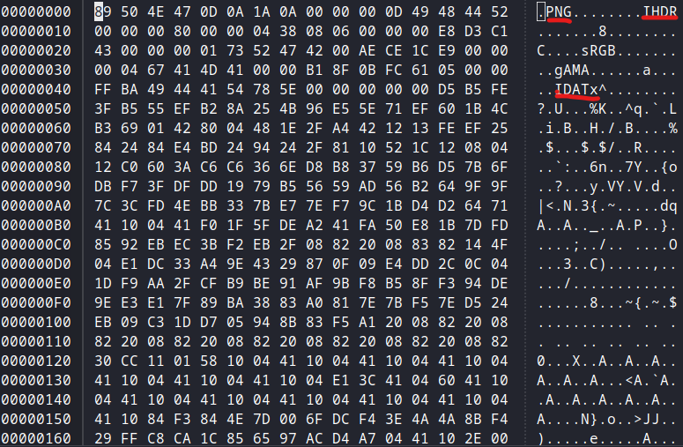

Finally this how it looks as I said there are 3 IDATx^ chunks correct all of them, u got the complete image.

After that we see that you will get the full screenshot and we see an encoded word in that picture. Then use Dcode cipher Identifier. We get to know that it is a FRACTIONATED MORSE CODE, Use the decoder of fractionated morse code.



4nD N0w U 6ot ThE Fl46!!!!

flag{GHEXFRACTIONATEDMORSEENCODER}

Challenge 2:

In the screenshot given we see that there are diffrent word lists in that one of it is "big.txt".

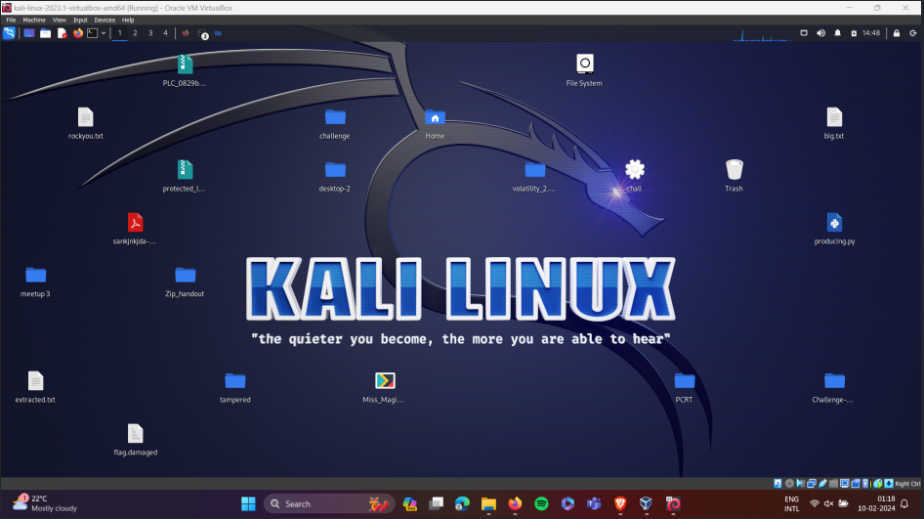

Use pdfcrack where the wordlist u use is big.txt.

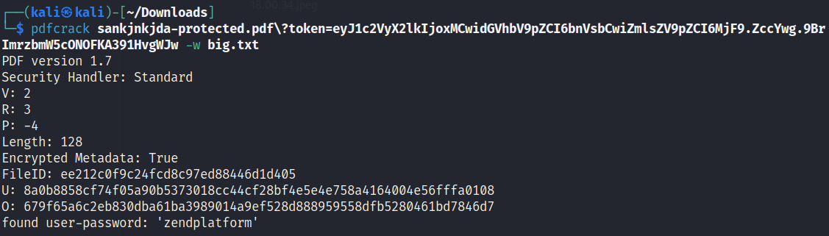

Use this password and open the pdf.

U 60T Th3 Fl46!!

Challenge 3:

If we see 496th packet, till then the DNS server was asking query which was asked by the victim 10.0.2.15

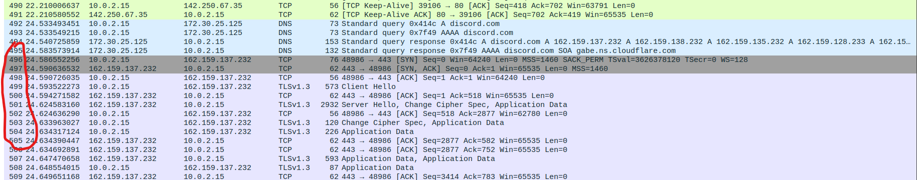

The attacker 162.159.137.232 attacked from packet no 496, all this happened in the dicord.. So I suspect this as the app.

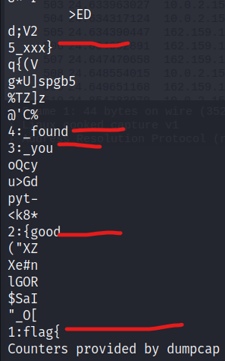

So now the flg is flag{good_you_found_xxx} now replace xxx with tha app name…

Challenge 4: HARD

The given pdf has a password so just use pdfcrack to get the password.

After opening it u will get a link to a google drive. Click on that there will be two folders one is filled with text, some of that is hidden too… So right click and drag over the file, u can see the hidden clue.

So if we see the image we see many websites, so slowly started to guess the password, I tried drive as passphrase.

After opening the embed file u see a link of google drive in that u have to download three files ‘nm’ ‘hard_2.pcapng’ and ‘hard-protected.pdf’.

So according to the nm file we have to find sender’s ip address. That is 10.0.2.15

Enter the pass word u get another link!!!!!!

Now use pdf crack to get the password of another PDF.

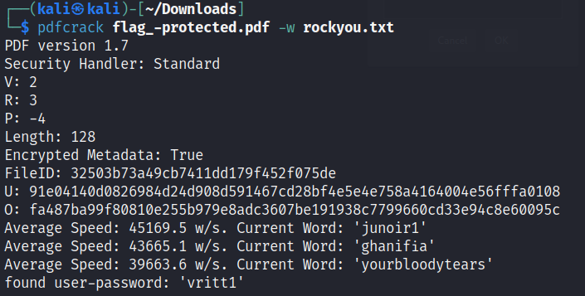

U get a text which tells the flag, that is “flag{flag}”.